We have partnered with Lorne Epstein (SHRM-SCP) to lead an experiential workshop on Uncovering Unconscious Bias Tuesday, August 9th, from 5:00 pm until 6:30 pm (Eastern Standard Time). We negotiated this workshop to be free for you and your guests. Yes, anyone who you know is welcome to join.

Register for free using the promo code SHRM2022 at the link below: https://www.eventbrite.com/e/uncovering-your-unconscious-bias-workshop-tickets-380422683487

Hands-on Workshop Description
In this workshop, participants learn what unconscious bias is and how it affects workplace relationships and decision-making. Research demonstrates that individuals who are highly aware of their decision-making process can see how unconscious bias influences their thinking. This awareness opens their mind to a broader set of choices and improves their ability to reach their intended outcomes.

Lorne will help you uncover your unconscious biases. You will come to understand the unconscious influences that are limiting the scope of your decision-making. You will learn and practice techniques designed to reduce bias and help you make better choices.

Learning Objectives
Through this workshop, participants will:
- Learn how priming bias works.
- See how bias can affect their choices at work.
- Conduct a personal social network analysis.
- Develop new practices and skills to minimize bias in business decisions.

About Lorne Epstein SHRM-SCP
Lorne is an HR and Organizational Development professional. He has spoken to thousands of HR professionals at local SHRM chapters and over a dozen state SHRM conferences. More than 9,500 HR professionals have taken this workshop since April of 2020. His Bias Impact report has been downloaded over 1000 times. Lorne has been leading experiential workshops since 1993 and has been an HR professional since 1996. As a leader in Talent Acquisition, he built recruiting teams in the U.S., India, and Brazil. He earned his master’s degree in organizational development from George Mason University. His graduate work focused on improving decision-making and reducing the impacts of unconscious bias in the workplace. His book, You're Hired! Interview Skills to Get the Job has been downloaded over a half-million times worldwide. He is a Lifetime Charter Member of the Association of Talent Acquisition Professionals.

Discount Code Instructions
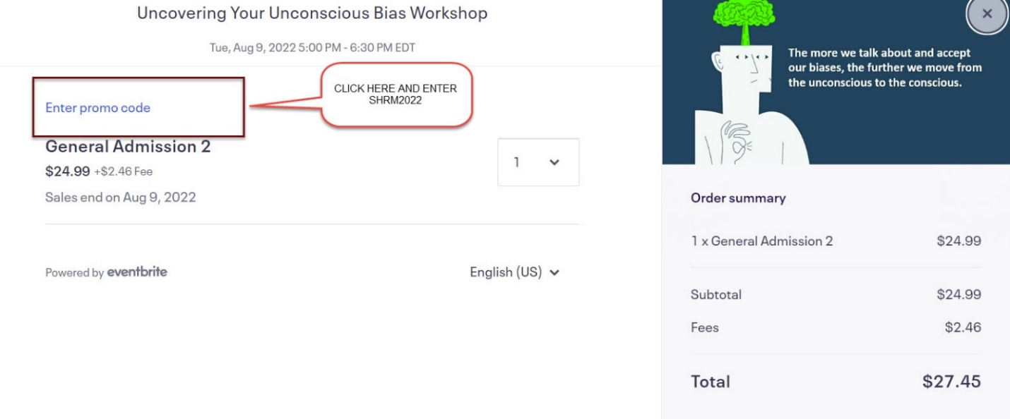

You must click Apply in the right corner after entering the discount code SHRM 2022
